VelocityManager Windows Installation Guide

Cambridge Petroleum Software 2013

Overview

VelocityManager software is controlled in its use by the Hasp Licence Manager software in conjunction with a USB Hasp key (sometimes called bit lock, or dongle), the ‘HaspHL net’. The Hasp licence manager software will identify the number of users at any time over the network, and also the presence of the encoded hardware Hasp key on a PC on the network.

To run the tutorial videos (which can be accessed from the “Help” menu or launched directly) a suitable media player must be installed, such as Windows Media Player.

The installation requires about 125mb HD space.

Requirements

- VM3D, the 3D visualisation component that comes with VelocityManager for Windows, requires the Microsoft .NET framework 4.0 or greater to be installed (Vista has it installed by default), and a graphics device that supports DirectX 8.1 or greater, with up to date drivers.

- The SEGY Converter also requires the .NET framework to be installed

- The video tutorials require a media player to be installed that supports .wmv video files (such as Microsoft’s Windows Media Player).

- Windows Installer 3.1 or higher.
Installing VelocityManager on a standalone workstation

- Completely uninstall all older versions of VelocityManager and remove all shortcuts.

- Run and install HASPUserSetup.exe

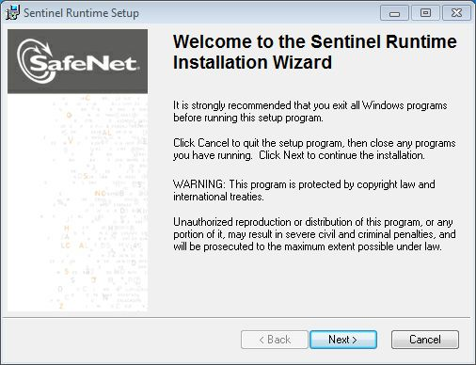

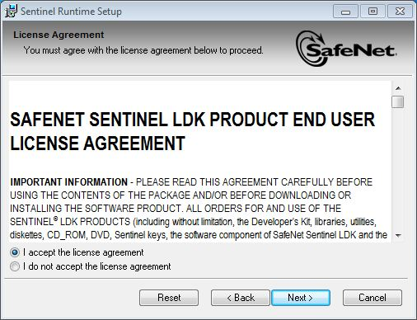

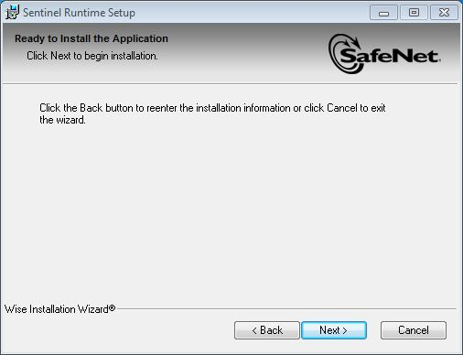

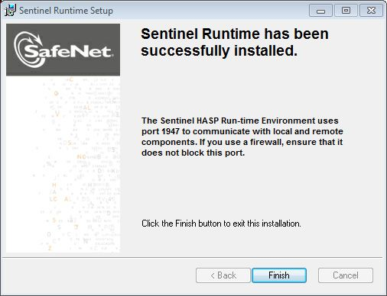

- Insert the USB HASP device.

- Connected HASP can be viewed by navigation to http://localhost:1947 in Internet Explorer.

- Install VelocityManager by running setup.exe.

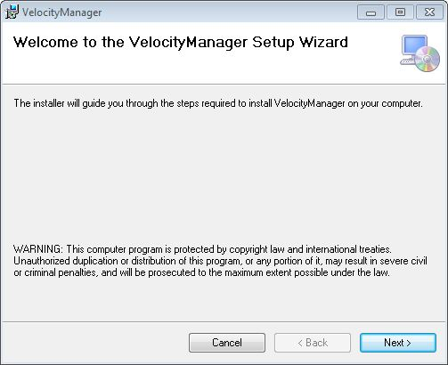

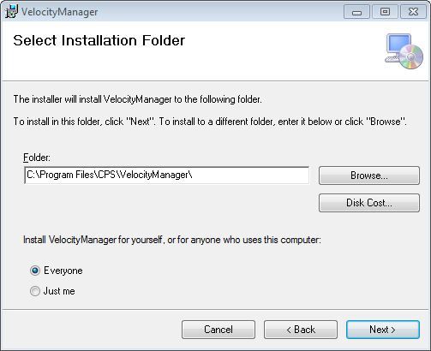

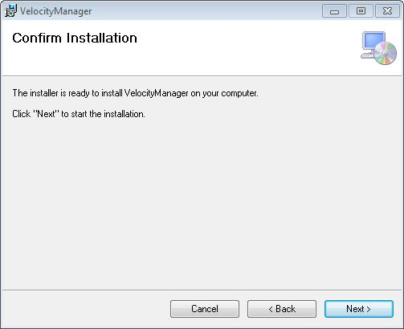

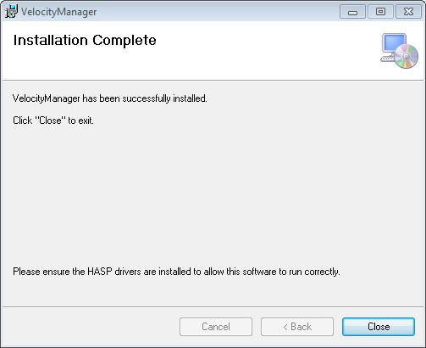

- Run and install HASPUserSetup_client.exe.

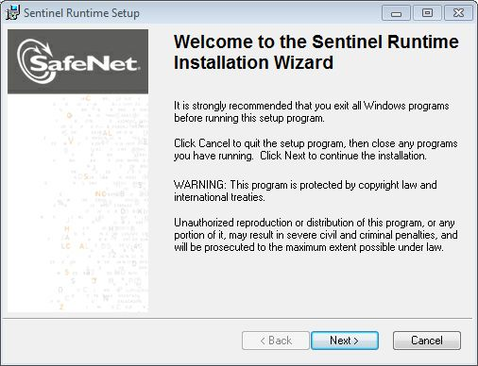

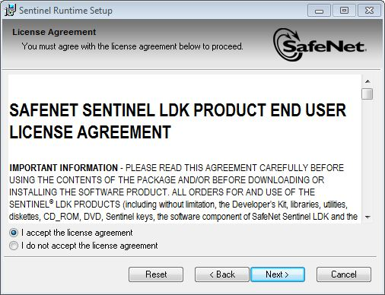

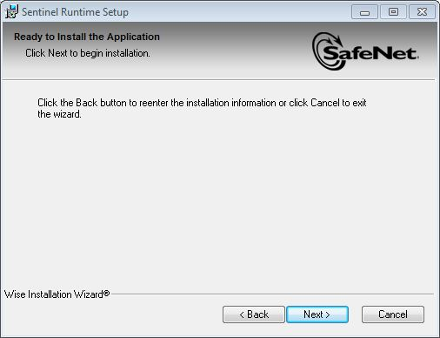

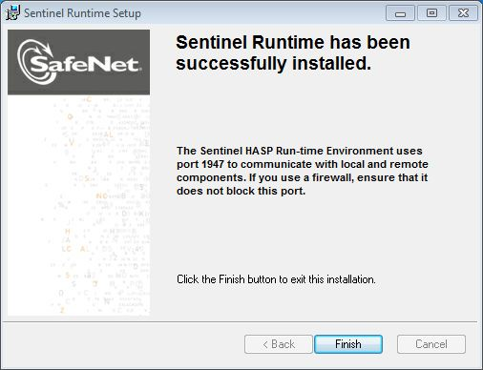

The files will be installed to the hard disc as indicated. The default directory is C:\Program files\CPS\VelocityManager

Files | Description
Velman.exe | Core executable
Velman.chm | Help file
Uninstall.bat | Uninstalls application
VelMan V5 SEGY filter.txt | Filter for reading SEGY output
VELMAN.FLT | Default filter file
HASPUserSetup_client.exe | Installs client HASP software
lmsetup_server.exe | Installs server HASP software
Folders
SEGY Converter | Application for converting SEGY files
VM3D | 3D visualisation files
VM_Training_Data | Sample data
Video tutorials | Videos files

The first time it is required the file VELMAN.FLT will be copied to the following location:

(Windows Vista and 7)
C:\Users\USERNAME\Documents\VelMan\Velman.flt
(Windows XP)
C:\Documents and Settings\USERNAME\My Documents\VelMan\Velman.flt

Ensure that each user has the appropriate privileges to launch the VelocityManager executable and also read/write to the project data.

